1 - Abra o docker-compose.yml

1.1 - Adicione dentro da configuração *services* mais uma configuração de banco de dados e image.
*basketdb:
image: redis:alpine
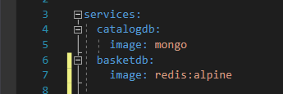

2 - Abra o docker-compose.override.yml

2.1 Dentro da configuração *services* adicione mais uma configurações referente ao container abaixo das configurações do *catalogdb:*
*basketdb:
container_name: basketdb
restart: always
ports:
-"6379:6379"
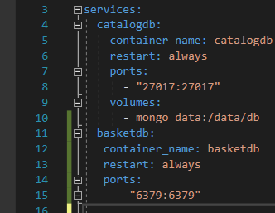

FINAL
Ao termino exlua todas as imagens containers e volumes do Docker desktop abra o docker-compose no terminal e digite o codigo abaixo para atualizar as imagens e conteiners
docker-compose -f docker-compose.yml -f docker-compose.override.yml up -d

___CODIGO FINAL___docker-compose.override.yml

version: '3.4'

services:
catalogdb:
container_name: catalogdb
restart: always
ports:
- "27017:27017"
volumes:
- mongo_data:/data/db

basketdb:
container_name: basketdb
restart: always
ports:
- "6379:6379"

catalog.api:
container_name: catalog.api
environment:
- ASPNETCORE_ENVIRONMENT=Development
- "DatabaseSettings:ConnectionString=mongodb://catalogdb:27017"
depends_on:
- catalogdb
ports:
- "8000:80"

basket.api:
container_name: basket.api
environment:
- ASPNETCORE_ENVIRONMENT=Development
- "CacheSettings:ConnectionString=basketdb:6379"
depends_on:
- basketdb
ports:
- "8001:80"

___CODIGO FINAL___docker-compose.yml

version: '3.4'

services:
catalogdb:
image: mongo

basketdb:
image: redis:alpine

catalog.api:
image: ${DOCKER_REGISTRY-}catalogapi
build:
context: .
dockerfile: Services/Catalog/Catalog.API/Dockerfile

basket.api:
image: ${DOCKER_REGISTRY-}basketapi
build:
context: .
dockerfile: Services/Basket/Basket.API/Dockerfile

volumes:
mongo_data:

